Study Material
<Program Code: CO/CM/CW/DE/EJ/ET/EN/EX/EQ/IE/IS/IC/MU>: <Course Code:22320><Course Name: Digital Techniques><Topic Name: Number Systems and code>
<UO1c. 1><study Material>

Course Expert: Mrs Rita Vora | Date:21/07/2020 | Mentor: Mr. K. P. Akole  Co-ordinator: Mrs Nirmala Kamble
Key words  BCD code  Excess -3 code  Gray code  ASCII code | Learning Objective:  To apply code conversion from given number system into other specified code such as Gray code, Excess-3 code, and ASCII code. | Conversion of Decimal Code to Binary Code, Gray Code, BCD Code and Excess-3 Code  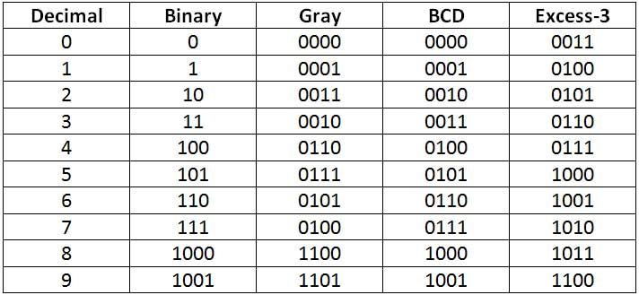
Key Questions  Q1. Define weighted and non-weighted code.  Q2. Do you know theGray code is used for error correction? | Concept Map  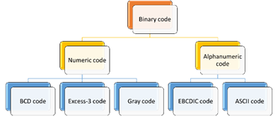
 | Codes  When numbers, letters or words are represented by a specific group of symbols, it is said that the number, letter, or word is being encoded. The group of symbols is called as a code. The digital data is represented, stored, and transmitted as group of binary bits. This group is also called as binary code. The binary code is represented by the number aswell as alphanumeric letter.  Numeric codes are used to represent numbers.  Alphanumeric codes are used to represent characters: Alphabetic letters and numerals. | Key Definitions  BCD code: In this code each decimal digit is represented by a 4-bit binary number.  Excess-3 Code: The Excess-3 code words are derived from the 8421 BCD code words by adding (0011)₂ or (3)10 to each code word in 8421.  Gray code: Itis defined as an ordering of the binary number system such that each incremental value can only differ by one bit.  ASCII Code: ASCII Code (American Standard Code for Information Interchange) is a 7-bit code and can represent 2⁷ = 128 possible characters and symbols.
Solved word Problem

Q1. Convert the following binary number into Gray code and Excess-3 code: 110100 , 1111
Gray code of 110100 is
101110
Excess-3 code is Adding (33)₁₀ to (52)₁₀ which is (85)₁₀ so Answer is 1000 0101

Gray code for 1111 is 1000
Excess-3 code is (1111)₂ =(15)_{10.}
Adding (33)₁₀ to (15)₁₀ gives (48)₁₀
i.e 0100 1000

 | Application of 1’s complement method  - Computerapplications  - Digital communication  - Analog to digital converters  - Error correction in digital communication  - Rotary and Optical encoders | Link to YouTube/ OER/ video  https://nptel.ac.in/courses/108/105/108105132/  click on lecture 28  https://www.tutorialspoint.com/computer_logical_organization/binary_codes.htm#:~:text=Error%20Correcting%20Codes-,Weighted%20Codes,a%20group%20of%20four%20bits.

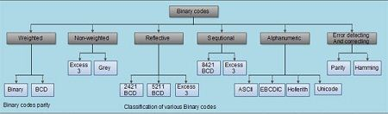
Classification of binary codes

The codes are broadly categorized into following four categories.
- Weighted Codes
- Non-Weighted Codes
- Reflective Codes
- Sequential Codes
- Alphanumeric Codes
- Error Detecting and correcting Codes

Weighted Codes
Weighted binary codes are those binary codes which obey the positional weight principle. Each position of the number represents a specific weight. Several systems of the codes are used to express the decimal digits 0 through 9. In these codes each decimal digit is represented by a group of four bits. The examples are Binary and BCD code.

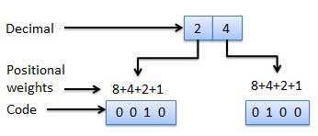

Non-Weighted Codes
In this type of binary codes, the positional weights are not assigned. The examples of non-weighted codes are Excess-3 code and Gray code.
Alphanumeric codes
The alphanumeric codes are the codes that represent numbers and alphabetic characters. Mostly such codes also represent other characters such as symbol and various instructions necessary for conveying information. An alphanumeric code should at least represent 10 digits and 26 letters of alphabet i.e. total 36 items. The following three alphanumeric codes are very commonly used for the data representation.
- American Standard Code for Information Interchange (ASCII).
- Extended Binary Coded Decimal Interchange Code (EBCDIC).
- Hollerith Code.

Reflective Code
It can be observed that in the 2421 and 5211 codes, the code for decimal 9 is the complement of the code for decimal 0, the code for decimal 8 is the complement of the code for decimal 1, the code for decimal 7 is the complement of the code for decimal 2, the code for decimal 6 is the complement of the code for decimal 3, the code for decimal 5 is the complement of the code for decimal 4, these codes are called as reflexive codes.

Sequential Codes
Sequential codes are the codes in which 2 subsequent numbers in binary representation differ by only one digit. The 8421 and Excess-3 codes are examples of sequential codes. 2421 and 5211 codes do not come under sequential codes.
Error detection and Correcting Codes

When digital data is transmitted from one system to another system an error my occur due to noise. To maintain the data integrity between transmitter and receiver ,extra bit or more than one bit are added in the date. These extra bits allow detection and sometimes correction of error in the data. The data along with the extra bits forms the code.
Codes which allow only detection of errors are called error correction codes and codes which allow detection and correction are called error detection and correction codes.

BCD(Binary coded decimal) Codes
In this code each decimal digit is represented by a 4-bit binary number.
BCD is a way to express each of the decimal digits with a binary code.
The positional weights associated to the binary bits in BCD code are 8-4-2-1 with 1 corresponding to LSB and 8 corresponding to MSB. These weights are actually 2³ 2² 2¹ 2⁰ which are same as those used in normal binary system.
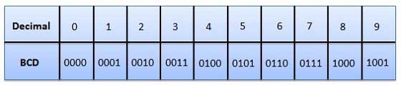
In the BCD, with four bits we can represent sixteen numbers (0000 to 1111). But in BCD code only first ten of these are used (0000 to 1001).
The remaining six code combinations i.e. 1010 to 1111 are invalid in BCD.

Example: convert (35)₁₀ into BCD
3 0011
5 0101
So (35)₁₀ = (00110101)_{BCD}

Binary to BCD Conversion
Steps
- Step 1 -- Convert the binary number to decimal.
- Step 2 -- Convert decimal number to BCD.
Example − convert (11101)₂ to BCD.

Step 1 − Convert to Decimal
Binary Number − 11101₂
Calculating Decimal Equivalent −
Step | Binary Number | Decimal Number
Step 1 | 11101₂ | ((1 × 2⁴) + (1 × 2³) + (1 × 2²) + (0 × 2¹) + (1 × 2⁰))₁₀
Step 2 | 11101₂ | (16 + 8 + 4 + 0 + 1)₁₀
Step 3 | 11101₂ | 29₁₀
Binary Number − 11101₂ = Decimal Number − 29₁₀

Step 2 − Convert to BCD
Decimal Number − 29₁₀
Calculating BCD Equivalent. Convert each digit into groups of four binary digits equivalent.
Step | Decimal Number | Conversion
Step 1 | 29₁₀ | 0010₂ 1001₂
Step 2 | 29₁₀ | 00101001_{BCD}
Result
(11101)₂ = (00101001)_{BCD}

BCD to Binary Conversion
Steps
- Step 1 -- Convert the BCD number to decimal.
- Step 2 -- Convert decimal to binary.
Example − convert (00101001)_{BCD} to Binary.

Step 1 - Convert to BCD

Step | BCD Number | Conversion
Step 1 | (00101001)_{BCD} | 0010₂ 1001₂
Step 2 | (00101001)_{BCD} | 2₁₀ 9₁₀
Step 3 | (00101001)_{BCD} | 29₁₀
BCD Number − (00101001)_{BCD}
Calculating Decimal Equivalent. Convert each four digits into a group and get decimal equivalent for each group.
BCD Number − (00101001)_{BCD} = Decimal Number − 29₁₀

Step 2 - Convert to Binary
Used long division method for decimal to binary conversion.
Decimal Number − 29₁₀
Calculating Binary Equivalent −
Step | Operation | Result | Remainder
Step 1 | 29 / 2 | 14 | 1
Step 2 | 14 / 2 | 7 | 0
Step 3 | 7 / 2 | 3 | 1
Step 4 | 3 / 2 | 1 | 1
Step 5 | 1 / 2 | 0 | 1
The remainders have to be arranged in the reverse order so that the first remainder becomes the least significant digit (LSD) and the last remainder becomes the most significant digit (MSD).
Decimal Number − 29₁₀ = Binary Number − 11101₂
Result
(00101001)_{BCD} = (11101)₂
Advantages of BCD Codes
- It is similar to decimal system.
- We need to remember binary equivalent of decimal numbers 0 to 9 only.
Disadvantages of BCD Codes
- The addition and subtraction of BCD have different rules.
- The BCD arithmetic is little more complicated.
- BCD needs more number of bits than binary to represent the decimal number. So BCD is less efficient than binary.

Excess-3 code
The Excess-3 code is also called as XS-3 code. It is non-weighted code used to express decimal numbers.
The Excess-3 code words are derived from the 8421 BCD code words by adding (0011)₂ or (3)10 to each code word in 8421
.
It is a sequential code because any code word can be obtained by adding binary 1 to its previous code.
In excess-3 code we get 9’s complement by just complementing each bit hence it is called self -complimenting code. The excess-3 codes are obtained as follows −

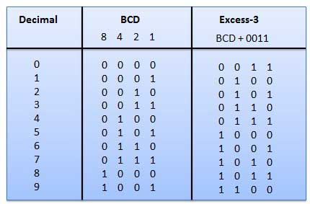
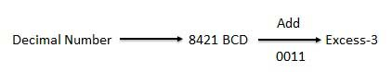

For example, to convert 15 to an excess-3 code, first 3 to be added to each digit as shown below.
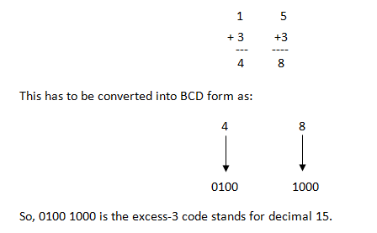

BCD to Excess-3 Conversion
Steps
- Step 1 -- Convert BCD to decimal.
- Step 2 -- Add (3)₁₀ to this decimal number.
- Step 3 -- Convert into binary to get excess-3 code.
Example − convert (0110)_{BCD} to Excess-3.

Step 1 − Convert to decimal
(0110)_{BCD} = 6₁₀

Step 2 − Add 3 to decimal
(6)₁₀ + (3)₁₀ = (9)₁₀

Step 3 − Convert to Excess-3
(9)₁₀ = (1001)₂
Result
(0110)_{BCD} = (1001)_{XS-3}

Excess-3 to BCD Conversion

Example − convert (10011010)_{XS-3} to BCD.
Steps
- Step 1 -- Subtract (0011)₂ from each 4 bit of excess-3 digit to obtain the corresponding BCD code.
Example − convert (10011010)_{XS-3} to BCD.
Given XS-3 number 1 0 0 1 1 0 1 0
Subtract (0011)₂- 0 0 1 1 0 0 1 1
1 1 1 1 1
--------------------
BCD = 0 1 1 0 0 1 1 1

Result
(10011010)_{XS-3} = (01100111)_{BCD}

Gray code
It is also known as Cyclic Code, Reflected Binary Code (RBC), Reflected Binary (RB) or Grey code – is defined as an ordering of the binary number system such that each incremental value can only differ by one bit.

In gray code, while traversing from one step to another step only one bit in the code group changes. That is to say that two adjacent code numbers differ from each other by only one bit.

Gray code is the most popular of the unit distance codes, but it is not suitable for arithmetic operations.

Gray code has some applications in analog to digital converters, as well as being used for error correction in digital communication. Gray codes are used in rotary and optical encoders.
Gray code to binary code conversion
Steps:
1. To convert Gray code to binary, bring down the most significant digit of the given Gray code number, because, the first digit or the most significant digit of the Gray code number is same as the binary number.
2. To obtain the successive second binary bit, perform the EX-OR operation between the first bit or most significant digit of binary to the second bit of the given Gray code.
3. To obtain the successive third binary bit, perform the EX-OR operation between the second bit or most significant digit of binary to the third MSD (most significant digit) of Gray code and so on for the next successive binary bits conversion to find the equivalent
Example:
Binary code of (01101)_{Gray}
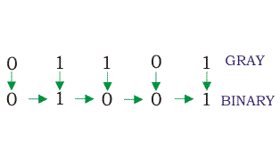
Binary to Gray code conversion
Steps:
1.To convert binary to Gray code, bring down the most significant digit of the given binary number, because, the first digit or most significant digit of the Gray code number is same as the binary number.
2. To obtain the successive Gray coded bits to produce the equivalent Gray coded number for the given binary, perform EX-OR operation between the first bit or the most significant digit of binary to the second one and write down the result next to the first bit of Gray code.
3.Repeat the step 2 until all binary bits hae been EX-ORed with their previous ones.

Example:

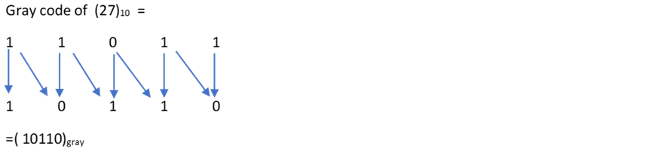

Table shows the 4 bit binary code and 4 bit Gray code for the decimals numbers from 0 to 15.

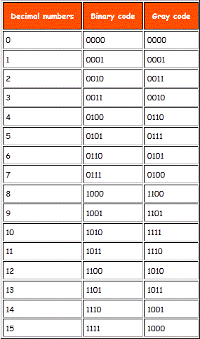

ASCII Code
ASCII Code(American Standard Code for Information Interchange) is a 7-bit code and can represent 2⁷ = 128 possible characters,
This code is sufficient to represent all the standard keyboard characters as well as control functions such as RETURN etc,
Table shows the partial listing of ASCII Code.
For example, ASCII Code for K is (1001011)2.

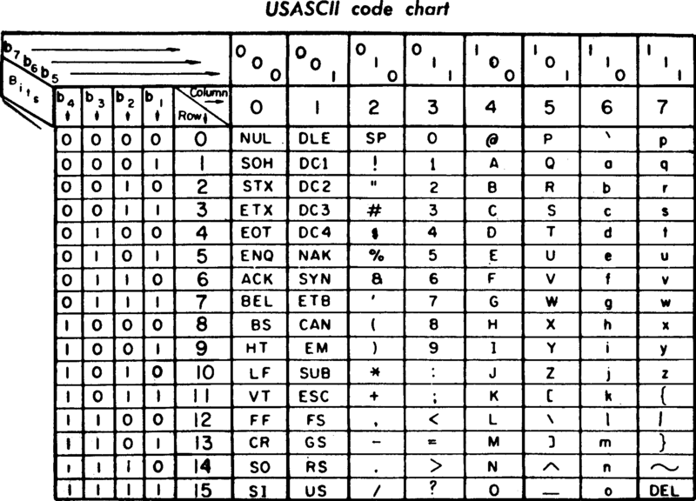

Key Take away
Classification of codes
BCD and Binary Codes are Weighted Codes
Gray and Excess-3 Codes are Non weighted codes
ASCII is Alphanumeric Code.
Conversion from one code to another.

